Step 4 - Faith
We don't know exactly where we are heading, but we know who guides us.
3/11/20253 min read
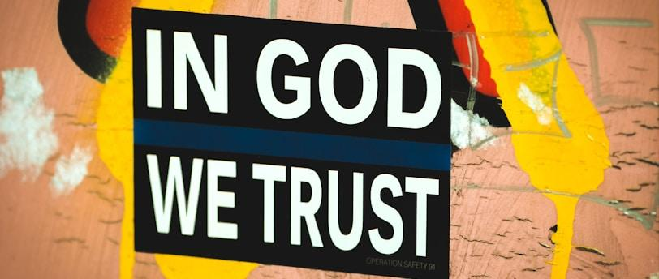

Step 4: Faith – The Foundation of the Christian Walk
Key Verse:
"Now faith is confidence in what we hope for and assurance about what we do not see." (Hebrews 11:1 - NIV)
In the previous step, we briefly discussed the fundamental role of faith in walking with Jesus through His Spirit. But what is faith? The writer of Hebrews provides the greatest biblical definition of this spiritual foundation. According to him, faith is confidence in what we hope for and assurance about what we do not see. If my goal here were theological knowledge, perhaps that would be enough. But I want you to reflect on how profound and impactful this definition can be.
Faith means that, even without visible evidence of something, we are gripped by an unshakable conviction about that truth, to the point of acting according to that belief. And in this sense, the father of faith, Abraham, is our greatest example. When called by God to leave his homeland, he had no idea where he was going but went anyway, trusting that the One who called him knew what He was doing (Hebrews 11:8). Now, imagine this: the Abraham who left Ur of the Chaldeans was a completely different person from the one who climbed the mountain willing to sacrifice his son, as he had heard from the Lord. He trusted that God would intervene to prevent that from actually happening. Many experiences shaped the character and attitude of this servant of God between these two episodes. However, from the very beginning, his relationship with the Lord was characterized by two things: recognizing God's voice and the willingness to obey it.
When we look at ourselves, if we are truly honest, we must recognize that circumstances, senses, desires, and needs strongly influence our decisions. It is difficult to imagine someone, in the face of an impossible situation, believing against hope and remaining firm in the conviction that God will bring us through the valley of the shadow of death intact under His protection. Or that we will be able to withstand the evil day and rise resurrected in the end. Christian hope may seem like madness. But it is not something we have on our own. It is given to us by the faith that God Himself grants us. It is not natural. That is why it is impossible to walk or take even a single step without faith, for, as the prophet Habakkuk said: "The righteous will live by his faith!" (Habakkuk 2:4).

What is faith?
Faith is more than an intellectual belief; it is an active trust in God and His promises. It allows us to see the invisible, touch the intangible, and achieve the impossible. Faith is the foundation of our relationship with God and how we receive His grace (Ephesians 2:8).

How do you grow in faith?
Again, these are just some hints to help you in this challenge. Nothing exhaustive:
- Hear God's Word: Faith comes from hearing the message of Christ (Romans 10:17).
- Practice obedience: Genuine faith is expressed through actions (James 2:17).
- Remember God's works: Recall how He has acted in the past and trust that He will act again.
- Persevere in trials: Faith is refined in the fire of difficulties (1 Peter 1:7).

Practical Example:
Abraham is called the "father of faith" because he believed against hope (Romans 4:18). His story teaches us that faith is not the absence of doubts but the decision to trust God despite them. When there is no hope at all, faith usually rises and changes everything!

Reflection Question:
"In what area of your life do you need to exercise more faith, trusting God even when you do not see the solution?"

Final Prayer:
Lord, increase my faith! Help me to trust in You even when everything around me seems uncertain. May I recognize Your voice and have the courage to obey, knowing that You are faithful. Amen.

